CROSSFIT SQUAMISH
Massage Therapy Health History

Name:_____________________________ Birthday_____/_____/_____ Today’s Date:______________
M D Y
Address:______________________________________________________________________________
Phone: (home)_________________________ (cell)________________________
Occupation/ Employer:__________________________________________________________________

How did you hear about our clinic?  CFS Client  Our Website  Friend _________________

❒ Health Care Practitioner_________________  Other ______________________________

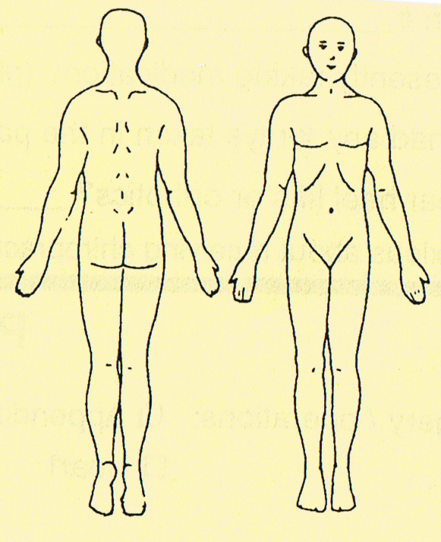 Please show location* *What is/are your primary concern(s)? ______________________________
______________________________________________________________
*When/how did it start?___________________________________________ ______________________________________________________________
______________________________________________________________
*What Aggravates it? ____________________________________________
*What Relieves it?_______________________________________________

*Major Illnesses/Surgeries/Accidents Date
_____________________________________ ___________________
_____________________________________ ___________________
_____________________________________ ___________________
_____________________________________ ___________________

*Is this visit related to an open: WCB case _______ or ICBC_______ case? Accident date? ___________
*Family Physician _____________________ Telephone ______________ Last Visit ________________
*Current Medications (name and what for) __________________________________________________

*What HEALTH CARE treatments do you use? (circle PAST or CURRENT, and write who you see)

RMT: P / C _______________________ Date of last Massage: ___________________
Physio: P / C _________________ Chiro: P / C _________________ Naturopath: P / C ______________ Acupuncture: P / C _________________ Other: P / C _________________________________________

…. You’re not done quite yet! Please complete the reverse side of this page.
THE FOLLOWING QUESTIONS ARE DESIGNED TO GIVE ME A BETTER UNDERSTANDING OF THE VARIOUS INFLUENCES ON YOUR HEALTH & HEALING:

*Please rate (1 to 10 scale- 10 is good/high) your: DIET ____ HYDRATION ____ STRESS ____ MOTIVATION ____ SLEEP _____ → What positions (please circle): Back Sides: R L Stomach
How well do you sleep?____________ How many hours a night on average?_____

*Do you: Drink alcohol? Y / N Smoke? Y / N Drink coffee? Y / N Drink Tea? Y / N
Eat grains? Y / N Eat dairy? Y / N Eat sugar? Y / N Eat meat? Y / N Take Ibuprophen? Y / N
Take other supplements? (e.g. Fish oils, Whey protein, MSM, Glucosamine, Creatine, Magnesium etc.)
Please list: ___________________________________________________________________________

*Do you get headaches? Y / N How many per week or month? ______ Where? _________________
*Do you work at a computer? Y / N Spend a lot of time driving? Y / N Grind your teeth? Y / N
Wear a mouth guard? Y / N For how long now? ______________ or stopped when? _____________
*Have you given birth? Y / N How many times? _____ Any difficult labours? ______C- sections? _____

*How many days a week do you exercise?______ Main activities (anything physical counts!): _____________________________________________________________________________________
*Are you usually sore after exercise? Y / N How many days/week do you stretch and/or do yoga? ____

*On a 1 -10 scale, how willing are you to take an active role in your recovery/maintenance of health? ____

PLEASE CHECK ANY OF THE FOLLOWING THAT ARE RELEVANT TO YOU IN THE PAST OR PRESENT

- Contact Lenses/glasses
- Blurred Vision
- Dizziness
- Low Blood Pressure
- High Blood Pressure
- Varicose Veins
- Constipation/Difficult bowel movements
- Shortness of Breath
- Phlebitis (inflam. of veins)
- Hardening of Arteries
- Muscle Cramps
- Lump in Throat
- Heart Conditions
- Respiratory Conditions
- Diabetes: Type 1 or 2? __
- Menstrual Problems
- Acute Inflamed Areas
- Cancer
- Aneurysm
- Blood Clots/D.V.T.
- Haemophilia
- Steel Pins/plates: where?_________
- Artificial Joints___________
- Tumors, Cysts
- AIDS/HIV
- Recent Infections
- Intestinal Problems
- Bruise Easily
- Loss of Skin Sensation/Tingling
- Skin Disease
- Contagious Diseases
- V.D./S.T.D
- Pregnant (Weeks______)
- Other_________________
________________________
- Allergies______________
________________________

YOUR APPOINTMENT time is reserved especially for you and may include time for assessment and homecare. If you need to reschedule or cancel an appointment, 24 hours notice is required so we may give this time to someone else. Otherwise it will be necessary to charge you for time lost. THANK YOU for your understanding!

I agree to pay for any appointment I miss, barring emergencies:

Signed:_______________________________________________ Date:________________

